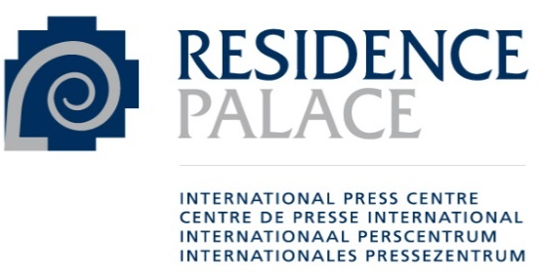

Residence Palace Talks for Journalists

Dear journalists and news editors,

We will soon be able to welcome you to the Residence Palace for a series of breakfast briefings on the theme of climate change and its impacts on our society, hosted by the Residence Palace – International Press Center, international, European and Belgian journalists’ organisations. This initiative is supported by the United Nations and the Federal Institute for Sustainable Development.

The urgency of addressing climate change and sustainable development are critical social and economic issues that captivate public interest. A large majority of journalists (over 81%) are “very concerned” about climate change, according to a global survey.

We are therefore offering a series of on-the-record briefings tailored for journalists and news editors, featuring expert speakers who will provide valuable insights and resources for constructive journalism.

These breakfast briefings will be interactive and informal. Participation will be limited to 20 to 30 participants, based on prior registration. We will keep the format as short and interactive as possible. The aim is to raise everyone's awareness in the context of an open debate. This will be neither a traditional conference nor a press conference for public broadcast or publication. The meetings will be ‘on the record’. Each participant will be free to use the content for journalistic purposes.

You will soon receive more details on the dates and the first topics to be discussed.

We look forward to seeing you.

Best regards,

Residence Palace - International Press Center
International Press Association (API)
European Federation of Journalists (EFJ)
International Federation of Journalists (IFJ)
Association des journalistes professionnels (AJP)
Vlaamse Vereniging van Journalisten (VVJ)
United Nations Regional Information Centre for Western Europe (UNRIC)
Institut fédéral pour le Développement durable / Federaal Instituut voor Duurzame Ontwikkeling (IFDD / FIDO)

